**CART : Classification And Regression Trees**

**Uygulama 1 :** Breast Cancer Wisconsin (Original) Data Set kullanilarak classification ve regration tree olusturuluyor.

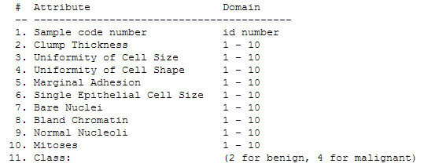

**Matlab Kod**

clear all;

close all;

clc;

dataset = load('breast-cancer-wisconsin.data');

train = dataset(:,1:10);

class = dataset(:,11);

classificationTree = fitctree(train,class)

view(classificationTree)

view(classificationTree,'mode','graph')

regressionTree = fitrtree(train,class);

view(regressionTree)

view(regressionTree,'mode','graph')

**Classification Tree**

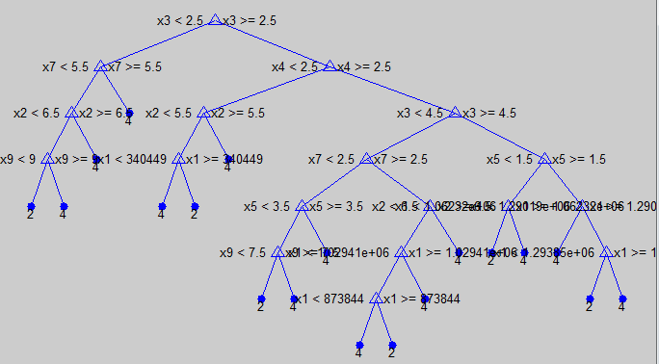

**Regression Tree**

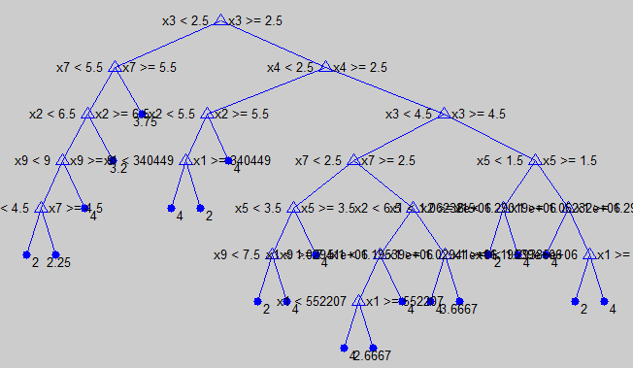

**Uygulama 2 :** Breast Cancer Wisconsin (Original) Data Set kullanilarak dogruluk, hata oranlari ve confusion matrix degerleri hesaplaniyor.

**Matlab Kod**

clear all;

close all;

clc;

dataset = load('breast-cancer-wisconsin.data');

dataEgitim = dataset(1:600,1:10);

dataTest = dataset(601:683,1:10);

classEgitim = dataset(1:600,11);

classTest = dataset(601:683,11);

tree = ClassificationTree.fit(dataEgitim, classEgitim)

t = classregtree(dataEgitim, classEgitim);

cvv = crossval(tree);

error = kfoldLoss(cvv)

dogruluk = 1 - error

c1 = tree.predict(dataTest);

cMat = confusionmat(classTest, c1)

error = 0.0517

dogruluk = 0.9483

cMat = 67 2

0 14

**Uygulama 3 :**

Matlab Kod

clear all;

close all;

clc;

x1 = [0 1 0 1 0 1 0 1]';

x2 = [0 0 0 0 1 1 1 1]';

x3 = [0 0 1 1 0 0 1 1]';

inData = [x1, x2, x3];

outData = ['-', '-', '+', '+', '+', '+', '-', '-']';

mytree = treefit(inData, outData, 'method', 'classification', 'splitmin', 2, 'prune', 'on', 'splitcriterion', 'gdi')

treedisp(mytree);

Decision tree for classification

1 if x1<0.5 then node 2 elseif x1>=0.5 then node 3 else -

2 if x2<0.5 then node 4 elseif x2>=0.5 then node 5 else -

3 if x2<0.5 then node 6 elseif x2>=0.5 then node 7 else -

4 if x3<0.5 then node 8 elseif x3>=0.5 then node 9 else -

5 if x3<0.5 then node 10 elseif x3>=0.5 then node 11 else -

6 if x3<0.5 then node 12 elseif x3>=0.5 then node 13 else -

7 if x3<0.5 then node 14 elseif x3>=0.5 then node 15 else -

8 class = -

9 class = +

10 class = +

11 class = -

12 class = -

13 class = +

14 class = +

15 class = -

